**LBW – DECISION MAKING OF CRICKET UMPIRES!**

**WHEN IN DOUBT – IT’S NOT OUT: AN OVERVIEW**

**Jeer Shri Karthick S Kirthika V Nithesh K**

**ABSTRACT:**

The overarching aim of this programme of research was to develop a deeper understanding of leg-before-wicket (LBW) decisions in elite-level cricket umpires. More specifically, this overview explores the historical LBW decision-making behaviour of elite-level cricket umpires to determine whether umpires’ decisions are impacted by contextual factors or biases (e.g., match format, expectations, home advantage), as well as the explicit decision-making expertise and beliefs of elite umpires. This overview says that the problem found in LBW whether the player goes to DRS

**KEY WORDS –** LBW, DRS, Pitching in line, Impact inline, Original Decision

**INTRODUCTION:**

This overview investigates LBW decision-making in elite-level cricket umpires, using both quantitative analysis of historical match data, and qualitative interviews with elite-level cricket umpires. LBW judgements are arguably the most difficult decisions umpires are required to make, and have been known to cause controversy with players, spectators, and the media. In spite of this, relatively few studies have explored LBW decision-making in elite-level umpires. This introductory chapter briefly outlines the background of LBW decision-making and sports officiating more generally and contextualises the research.

Cricket is one of the most popular sports in the world, with over 300 million participants world-wide (ICC, 2018). At the elite-level, players, spectators, and the media scrutinise how umpires perform, particularly in relation to their decision making. One of the most difficult, and often controversial, decisions that make umpire are LBW judgements. Uniquely to cricket, **LBW decisions also include a predictive spatial judgement as to where the ball would have travelled had it not hit the batter**. This contrasts with the majority of sports officiating studies that have generally focused on decisions where the official makes only a reactive judgement based on their immediate perceptual experience. **LBW decisions are complex, and can impact the outcome of a game, and yet there is limited understanding of the expertise of cricket umpires in this domain.** Specifically, few studies have explored the decision-making behaviour, and decision-making process of elite level of cricket umpires.

**PROBLEM DESCRIPTION:**

While the Batsman performing well, at the same time the ball hits batsman leg and the Umpire gave out but the original decision is **NOT OUT**. At that moment the striker choose DRS to check the Umpires decision. DRS says that the ball is pitching in line and also impact in line and original decision is not out but the wickets turns into Umpires call.

Here third umpire review was not satisfied because the original decision is out but they gave umpires call. This is the overall problem of this cricket Domain.

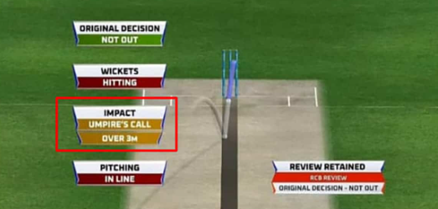

**HYPOTHESIS:**

The Hypothesis of this overview was to further understand the LBW decision-making process, and decision-making behaviour of elite-level cricket umpires. A large historical dataset was utilised in the first three studies to explore the LBW decision making behaviour in the performance environment and to identify any areas of bias relating to match format, expectations, and home advantage. The final study explored elite-level cricket umpires’ beliefs about how they make LBW decisions.

**ALGORITHM USED FOR LBW DECISION:**

HAWK – EYE:

The Hawk-eye is a multi-sport ball tracking technology invented by Dr Paul Hawkins and is used in sports such as tennis, football and cricket - among many others. In cricket, it is used to determine the **predictive path of the ball** with respect to the stumps, for making LBW decisions.

The hawk-eye, with the help of 6 cameras – three placed at each end of the ground - records the visuals of every delivery bowled, and the data obtained by the computers linked to the cameras is used to determine the predicted path of the delivery after pitching and impact on the pads.

When an appeal for LBW is made by the bowler and the on-field umpire refers it to the TV umpire, the visual representation of this predicted path guides the third umpire in passing his judgement.

The point to be noted here is that, while constant attempts are being made to improve its efficiency by using higher frame rate ultra-motion cameras, the Hawkeye or any other ball tracking technology is still a work in progress, does not provide totally conclusive evidence and can only be used as a guiding tool that provides the umpire with predictive path of the ball for making a better judgement. Therefore, in the case of marginal decisions, the on-field decision will always be given priority.

**LIMITATIONS:**

**1.** Much like every other piece of technology these days, the Hawk-Eye is not perfectly accurate. However small, there will always be some amount of error present in the system. For example, combined with the stump mics and the motion-sensor technology, there is a chance that an edge didn’t occur but got picked up by the Hawk-Eye when it was actually another sound.

**2.** It is an overly expensive piece of technology and not actually affordable in every cricket stadium around the world.

**3.** There is an argument that with computerized technology involved, the “natural” beauty of sport is being diminished. It is also a way of challenging the umpire’s decision and that might dent the integrity of the individual and the sport on occasion.

**RULES OF LBW:**

There are some rules of LBW

When bowler bowls, if batsman is just front of stumps and ball hit directly to the legs without touching bat first then there are some conditions:

1.Pitching

2. Impact

3. Wickets hitting or not

**Pitching**- If pitching is outside leg then it is not out otherwise it's out

**Impact**- If impact is outside the stumps then it's not out and if it's in stumps then it's out

**Wickets hitting**- This is same as impact.

Now the rule of Umpire’s call:

If pitching impact or hitting wicket is not clearly visible or 50% case then deduction goes to Umpires original decision but review is retained.

**FOR NOT OUT:**

The most important thing to start is, if it is NO BALL, you cannot be given out, it should be a legal delivery.

If bat or gloves is involved first before hitting the pad, no matter what, it should not be given out.

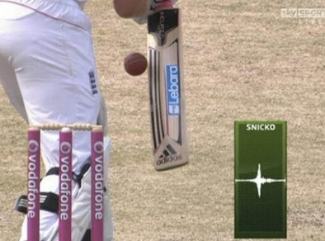

3. If the ball is pitching outside leg stump, whether you are playing the shot or not, you can’t be given out.

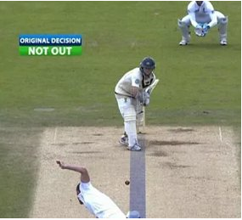

4. If the impact of the ball is not within the stumps and you are playing a shot, you cannot be given out under any condition

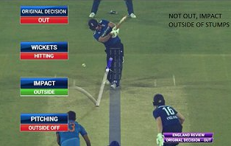

5. If less than half of the stumps is clipped by a ball, you cannot be given out.

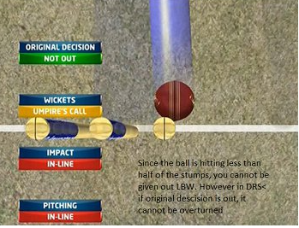

**FOR OUT:**

Foremost criteria should be It has to be a legal delivery to start with and also appeal is made by the fielding side.

1. **When shot is played by the batsman:**

The impact of the ball should be in line with the stumps (half or more than half of the ball) provided it has not pitched outside the leg stump. After that it should be not too high and should be clipping half or more of any of the stumps.

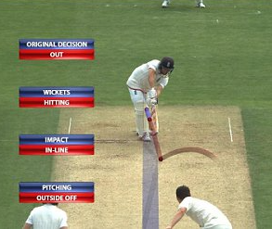

**2. When shot is not played by the batsman:**

The impact of the ball doesn’t matter here as long as the ball has not pitched outside the leg stump. After that it should be not too high and should be clipping half or more of any of the stumps.

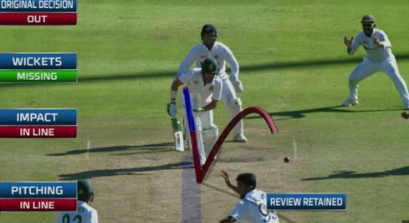

**CONCLUSION:**

There was no statistically significant difference in umpires' performance when comparing the front foot condition to the back foot condition but performance for the ‘no foot’ condition was significantly better than for the front foot condition.

These results suggest that umpires' performance judging LBW dismissals would be improved if they did not have to monitor bowlers' feet to adjudicate ‘no‐ball’ deliveries but there would be no benefit from a reversion from the current ‘front foot’ no‐ball law to the previously used back foot law.

Umpires were able to differentiate between **“out”** and **“not out”** appeals to a high standard but were conservative and had a bias to respond “not out” in all formats of the game. Umpires were less accurate in the shorter formats of the game, particularly T20 cricket and were also significantly more conservative in T20 compared to Four-day Matches.